**EXP. 4: GENERATION, WINDOWING & TIME OPERATIONS OF SIGNALS**

|  |
| --- |
| **Name of the Student : VISHWAS VASUKI GAUTAM** |
| **ID No. : 2019A3PS0443H** |

**Objectiv**e(s):

1. Generation of different Continuous time signals used in signals and systems course
2. Generation of even & odd components of a given signal
3. Understanding windowing effect
4. Draw the given signal and perform time operations
5. Determine the power and energy of a given signal

|  |
| --- |
| ***Note:***  (1) *While writing the Matlab code in* ***Editor window*** *follow the below instructions :*  *(i) (a) use only built-in Matlab functions (if available) otherwise (b) use logical/relational operators*  *&*  *(ii) avoid using control loops, as they take more time in running the program*  *(2) Use* ***HELP*** *option / search documentation of Matlab* |

**Run #01: Signals.**

Q1. Write a MATLAB code to generate the following signals. Plot the signals using subplot / axis / grid / x-label, y-label/ title of the plot

1. Unit step (ii) Unit impulse (iii) Unit ramp

(iv) Triangular (v) Square signal (vi) Sinc signal

(vii) Sawtooth signal with amplitude = 1 and time period = 0.5

|  |
| --- |
| Answer (paste the written code and plots) :  t = (-2:0.01:2)';  impulse = (t==0);  unit_step = (t>=0);  unit_ramp = t.*unit_step;  saw_tooth = sawtooth(12*t);  triangle = (1+t).*(t>=-1 & t<0) + (1-t).*(t>=0 & t<1);  square_signal = square(t);  sine_signal = sinc(t);  plot(t,[impulse unit_step unit_ramp saw_tooth triangle square_signal sine_signal]) |

Q2. Write a MATLAB code to plot the following signals.

(i) sin(2 $π$ t) (ii) sin(2 $π$ t)+cos(10 $π$ t)

(iii) exp(j2 $π$ t) (iv) exp(j2 $πt$/3) + exp(j3 $π$ t/4)

Display the fundamental time period of these signals.

|  |
| --- |
| Answer (paste the written code and plots) :  t = (1:0.01:10);    w = sin(2*pi*t);  x = sin(2*pi*t) + cos(10*pi*t);  y = exp(1i*2*pi*t);  z = exp(1i*2*pi*t/3) + exp(1i*3*pi*t/4);    timeperiod_w = (2*pi)/(2*pi);  timeperiod_x = gcd(int16((2*pi)/(2*pi)), int16((2*pi)/(10*pi)))  timeperiod_y = (2*pi)/(2*pi);  timeperiod_z = gcd(int16((2*pi)/(2*pi/3)),int16((2*pi)/(3*pi/4)))      clf  subplot(411);  plot(t, w)    subplot(412);  plot(t, x)    subplot(413);  plot(t, y)    subplot(414);  plot(t, z) |

**Run #02: Even & odd components of a given signal**

Q3. Write a MATLAB code to generate the even and odd components of the following signals

**Note** : Use ***heaviside*** built-in function available in Matlab for plotting signals related to

step function

(i) u(t) (ii) t u(t) (iii) sin(ω0t) u(t)

|  |
| --- |
| Answer (paste the written code and plots) :  t = (-1:0.1:1);  step_function = heaviside(t);  step_function_even = (heaviside(t) + heaviside(-t))/2;  step_function_odd = (heaviside(t) - heaviside(-t))/2;  ramp_function = t.*heaviside(t);  ramp_function_even = (t.*heaviside(t) + (-t).*heaviside(-t))/2;  ramp_function_odd = (t.*heaviside(t) - (-t).*heaviside(-t))/2;  sine_function = sin(2*pi*t).*heaviside(t);  sine_function_even = (sin(2*pi*t).*heaviside(t) + sin(-2*pi*t).*heaviside(-t))/2;  sine_function_odd = (sin(2*pi*t).*heaviside(t) - sin(-2*pi*t).*heaviside(-t))/2;  clf  subplot(311);  plot(t, [step_function], t, [step_function_even], t, [step_function_odd]);  subplot(312);  plot(t, [ramp_function], t, [ramp_function_even], t, [ramp_function_odd]);  subplot(313);  plot(t, [sine_function], t, [sine_function_even], t, [sine_function_odd]); |

**Run #03 : Windowing effect on a given signal**

**Q4.** (i)Write the expression x(t) for a sine wave signal of frequency 0.5 Hz, starting at time = -5

sec and ending at time = 10 seconds and reaching a maximum value of 4 volts peak to

peak.

(ii) Generate the same sine wave signal using matlab code and plot, showing the time and amplitude scales and give the title as “signal x(t)”.

1. Write Matlab code to generate a rectangular windowed signal y(t) for time t = -2 sec to t = 2 sec plot it in same figure of x(t) using *subplot* command (as shown in below figure 1). Show the time scale and labels. Index the plots using “text” command and draw grid.

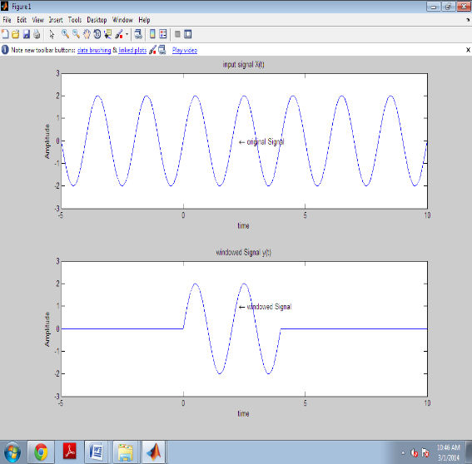

Figure 1

|  |
| --- |
| Answer (paste the written code and plots):   1. When -5 < t < 10:   x = 4sin(pi t)   1. t = -5:0.1:10;   x = 4*sin(pi*t);  subplot(211);  plot(t,x)  xlabel("time "), ylabel("amplitude")  title("signal x(t) ")   1. y = 4*sin(pi*t).*(t<=2 & t>=-2);   subplot(212);  plot(t,y)  xlabel("time "), ylabel("amplitude")  title("signal y(t) ") |
|  |

**Run #04: Signal operations**

Q5. Write the matlab code and

(i) obtain the expression x(t) for the given continuous-time signal (shown below) using relational / logical operators and plot it

(ii) Perform the given operations on obtained signal x(t)

(i) x(t - 1) (ii) x(2 - t) (iii) x(2t + 1) (iv) x(4 - t/2)

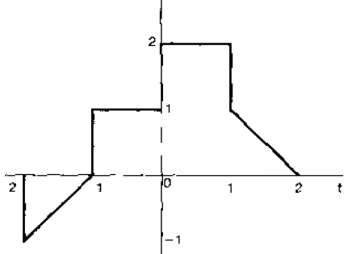

|  |
| --- |
| Answer (paste the written code and plots):  (i)  t = (-2:0.1:2)';  x = (t>=-2 & t<=-1).*t + (t>-1 & t<=0).*1 + (t>0 & t<=1).*2 + (t>1 & t<=2).*(-t);  clf  subplot(511)  plot(t,x) |

**Link to upload files**

**Tuesday Batch** [**https://forms.gle/E85Ym6rZ3dvjkZDD8**](https://forms.gle/E85Ym6rZ3dvjkZDD8) **Sunday of the week in which you perform this experiment mostly March 14th 5 PM**

**Thursday batch <https://forms.gle/97mPxTvCAdnvUcby7> Due on Feb 21st 5 PM**

**Try Yourself**

Q6. Write a MATLAB code to plot the following signals.

(i) cos(10 $π$ t) (ii) jexp(j10t) (iii) 3exp ($\frac{3}{5}(t+\frac{1}{2}))$.

Display the fundamental time period of these signals.

Q7. Write a MATLAB code to generate the even and odd components of the signal cos(ω0t) u(t)

Q8. Write a MATLAB code to calculate the ***energy*** and ***power*** of the following signals.

(i) sin (t) (ii) exp (j10t) (iii) log (t) (iv) u(t)

(vi) saw-tooth signal of amplitude 3 and time period = 20s.